

**Session : 2023 – 2024**

Ravel : The Music Buddy

**A PROJECT REPORT**

**Submitted By**

Abhishek Sagar(2115000026)

Aditya Singh(2115000078)

Aman Kumar(2115000130)  
 Shikha Chauhan(2115000995)

***partial fulfillment for the award of the degree of***

##### BACHELOR OF ENGINEERING

**IN**

Computer Engineering & Applications

( Institute of Engineering & Technology )

**GLA University, Mathura - 281406**

## BONAFIDE CERTIFICATE

This is to certify that the project entitled “**Ravel : The Music Buddy**”, carried out as Mini Project - I, is the bonafide work of “**Abhishek Sagar, Aditya Singh, Aman Kumar and Shikha Chauhan**” who carried out the project work under my supervision.

##### SIGNATURE SIGNATURE

Dr. Rohit Agrawal Mr. Ankit Arora

**HEAD OF THE DEPARTMENT SUPERVISOR**

Department of Computer Engineering Technical Trainer & Application (GLAU) (GLAU)

## ACKNOWLEDGEMENT

We would like to express our deep sense of gratitude and respect towards **Mr. Ankit Arora**, Technical Trainer, Computer Science & Engineering Department for guiding and encouraging us throughout the project.

His sincerity and determination has been a constant source of inspiration for us. We also believe that he will empower us with all his great innovative ideas and different stages of the project. We would not like to miss the opportunity to thank and acknowledge the contribution of all the faculty members of the department for their kind guidance and co-operation.

##### Abhishek Sagar ( 2115000026 )

##### Aditya Singh (2115000078)

##### Aman Kumar (2115000130)

##### Shikha Chauhan (2115000995)

**Abstract**

## TABLE OF CONTENTS

**Graphical Abstract Abbreviations**

**Chapter 1. Introduction**

* 1. Overview
  2. Background Study
  3. Project Planning
  4. Timeline
  5. Organization of Report

**Chapter 2. Goals and Objectives**

* 1. Problem Statement
  2. Goals and Objective

**Chapter 3. Design Flow**

* 1. Hardware & Software Requirements
  2. Project Design

**Chapter 4. Technologies**

**Chapter 5. Conclusion Chapter 6. Future Work**

**References**

## ABSTRACT

"Ravel: The Music Buddy" is an innovative music streaming platform designed to redefine the way users engage with and discover music. This project aims to create a dynamic and user-friendly environment where music enthusiasts can seamlessly stream their favorite tunes while also exploring new tracks based on their preferences. The platform combines cutting-edge technology with an intuitive user interface to deliver an immersive and personalized music experience.

The project titled "Ravel: The Music Buddy" aims to revolutionize the music streaming experience by developing a comprehensive and user-friendly web-based platform. The primary focus is on optimizing user engagement through personalized music recommendations, efficient content organization, and high-quality audio streaming. The system incorporates state-of-the-art recommendation algorithms, including collaborative filtering and content-based filtering, to tailor music suggestions based on individual user preferences and behaviors.

The platform's key features include a diverse music library covering songs, albums, and playlists across various genres and artists. Users can seamlessly create accounts, build profiles, and enjoy a hassle-free registration process. The project also emphasizes social interaction by enabling playlist sharing and collaborative playlist creation, fostering a sense of community among music enthusiasts.

To enhance the user experience, the system provides a robust search functionality, allowing users to find specific songs, albums, or artists effortlessly. Additionally, the implementation of high-quality audio streaming with customizable settings ensures an optimal listening experience. The project's success will be measured by its ability to deliver a user-friendly environment, a vast music catalog, and a secure platform that complies with data protection regulations.

The development process involves using HTML, CSS, JavaScript, and relevant frameworks for the frontend, while Python and JavaScript, along with necessary libraries, are employed for backend development. MongoDB serves as the database management system for efficient data storage and retrieval. The project follows a meticulous implementation plan, covering project initiation, frontend and backend development, database design and setup, API implementation, and final testing and debugging.

With a team comprising Abhishek Sagar, Aditya Singh, Aman Kumar, and Sikha Chauhan, the project is set to be supervised by Mr. Ankit Arora. The expected outcomes include a user-friendly music platform with a diverse music library, personalized recommendations, and robust features aimed at enhancing user engagement and satisfaction. "Ravel: The Music Buddy" strives to create a seamless and enjoyable music streaming experience while prioritizing data security and legal compliance.

# GRAPHICAL ABSTRACT

# 

## ABREVIATIONS

|  |  |
| --- | --- |
| HTML | Hyper Text Markup Language |
| CSS | Cascading Style Sheet |
| JS | Java Script |

Chapter – 1

**Introduction**

**1.1 Overview**

In a world increasingly defined by the digital symphony of interconnected technologies, "Ravel: The Music Buddy" emerges as a transformative force in the realm of music streaming. This innovative project seeks to redefine the conventional paradigms of music engagement, presenting a dynamic and user-centric platform designed for music enthusiasts to seamlessly stream their favorite melodies while embarking on a personalized journey of discovery. With an unwavering commitment to delivering an unparalleled user experience, "Ravel" combines cutting-edge technological prowess with an intuitive interface, promising an immersive and tailored musical odyssey.

In this era of ever-evolving digital landscapes, the platform stands as a testament to the vision of creating a space where users not only consume music but actively engage with it. The aim is to transcend the boundaries of traditional streaming services by introducing intelligent search functionalities, personalized playlists, and machine learning-driven recommendations. "Ravel: The Music Buddy" envisions a future where music becomes not just an auditory delight but a deeply personalized and communal experience, fostering connections between users and the diverse world of music genres. This overview sets the stage for a detailed exploration of the features, technologies, and aspirations that define the essence of "Ravel" as a revolutionary music streaming companion.

##### Project Planning

The development and execution of "Ravel: The Music Buddy" adhere to a meticulously crafted project plan, outlining the key milestones, tasks, and timelines essential for the successful realization of our vision. This section provides an insight into the comprehensive planning that underpins the project's journey.

##### Timeline

|  |  |
| --- | --- |
| 06 Nov – 07 Nov | Requirement Specification, Built up Model |
| 08 Nov – 12 Nov | Designing of Website and User Interface |
| 13 Nov – 25 Nov | Implementation started. Started building website. |
| 25 Nov – 27 Nov | Completed Project. Testing. User Review. |
| 27 Nov – 1 Dec | Project Presentation and Report Submission. |

**Organization of Report:**

**Chapter 1** gives the introduction to the project specifying the need of the project, various problems which would be solved through the project and the various tasks required to be performed for completion of the project. It also tells the timeline of various activities performed.

**Chapter 2** specifies the problem statement and the goals and objectives of the project.

**Chapter 3** gives details about the model and design of the project. Various constraints are also discussed here. It gives the structure of the website. It provides all the details about each section provided in the website.

**Chapter 4** talks about how the design is implemented using various technologies. Chapter 5 concludes the project and gives the future scope.

**Chapter-2**

## GOALS AND OBJECTIVES

##### Problem Statement

The problem statement for the "Ravel: The Music Buddy" project revolves around the challenges users face in discovering, organizing, and playing their favorite music tracks. The existing landscape might lack a user-friendly interface that seamlessly integrates diverse music catalogs, offers high-quality audio streaming, and provides personalized music recommendations based on user preferences and listening history. The need for a comprehensive music player that combines functionality, user-friendliness, and a robust recommendation system is the core problem that the project aims to address.

##### Goals and Objectives

1. **Optimize User Experience:** Streamline music discovery and playback processes to enhance the overall user experience. Implement an intuitive and user-friendly interface to minimize user effort and improve navigation.
2. **Personalize Music Recommendations:** Develop a robust recommendation system to provide personalized music suggestions based on user preferences and listening history. Prioritize user engagement by tailoring recommendations to individual tastes and behaviors.
3. **Efficient Content Organization:** Build a comprehensive music library with a diverse catalog of songs, albums, and playlists across various genres and artists. Implement efficient categorization based on genre, mood, and other relevant metadata to facilitate easy content discovery.
4. **High-Quality Audio Streaming:** Support high-quality audio streaming with customizable audio settings to ensure an optimal listening experience for users. Prioritize the delivery of clear and crisp audio for an immersive music playback.
5. **Security and Privacy Measures:** Implement strong security measures to protect user data and privacy. Ensure compliance with data protection regulations, building trust among users regarding the confidentiality and security of their information.
6. **Search Functionality:** Enable users to search for specific songs, albums, or artists efficiently, enhancing the accessibility of the music catalog.
7. **Free of Cost Accessibility:** Provide free access to the platform to maximize user reach and engagement.
8. **Collaborative and Hybrid Recommendation Approaches:** Implement collaborative filtering and content-based filtering to offer a more accurate and diverse range of music recommendations.
9. **Project Success Metrics:** Gauge success based on the platform's ability to deliver a diverse music library, high-quality audio streaming, and a user-friendly environment while maintaining data security and legal compliance.

**Chapter-3**

# DESIGN FLOW

* 1. **Hardware and Software Requirements**
     + JavaScript, HTML, CSS
     + VSCode
     + Version Control: GitHub
     + Processor: intel core i5
     + Minimum 4GB RAM
     + Operating System: Microsoft Windows 11

# Project Design

The website has various sections such as: -

1. Home Page
2. Dashboard
3. Trending Now
4. Albums
5. Top Artist
6. Top Charts
7. New Release
8. Top Search Artist
9. Popular In Hindi
10. Search Bar

**Fig 1. Website Banner & Logo**



**Fig 2. Home Page**

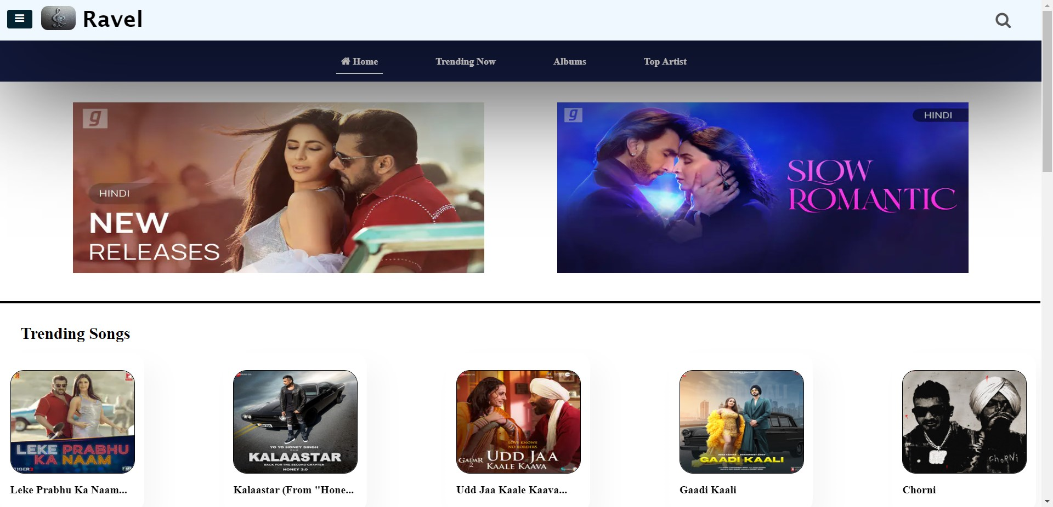

**Fig 3. Dashboard**

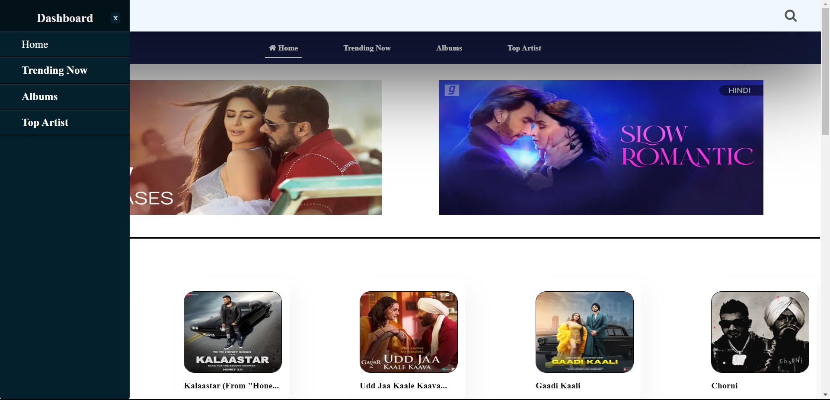

**Fig 4. Albums**

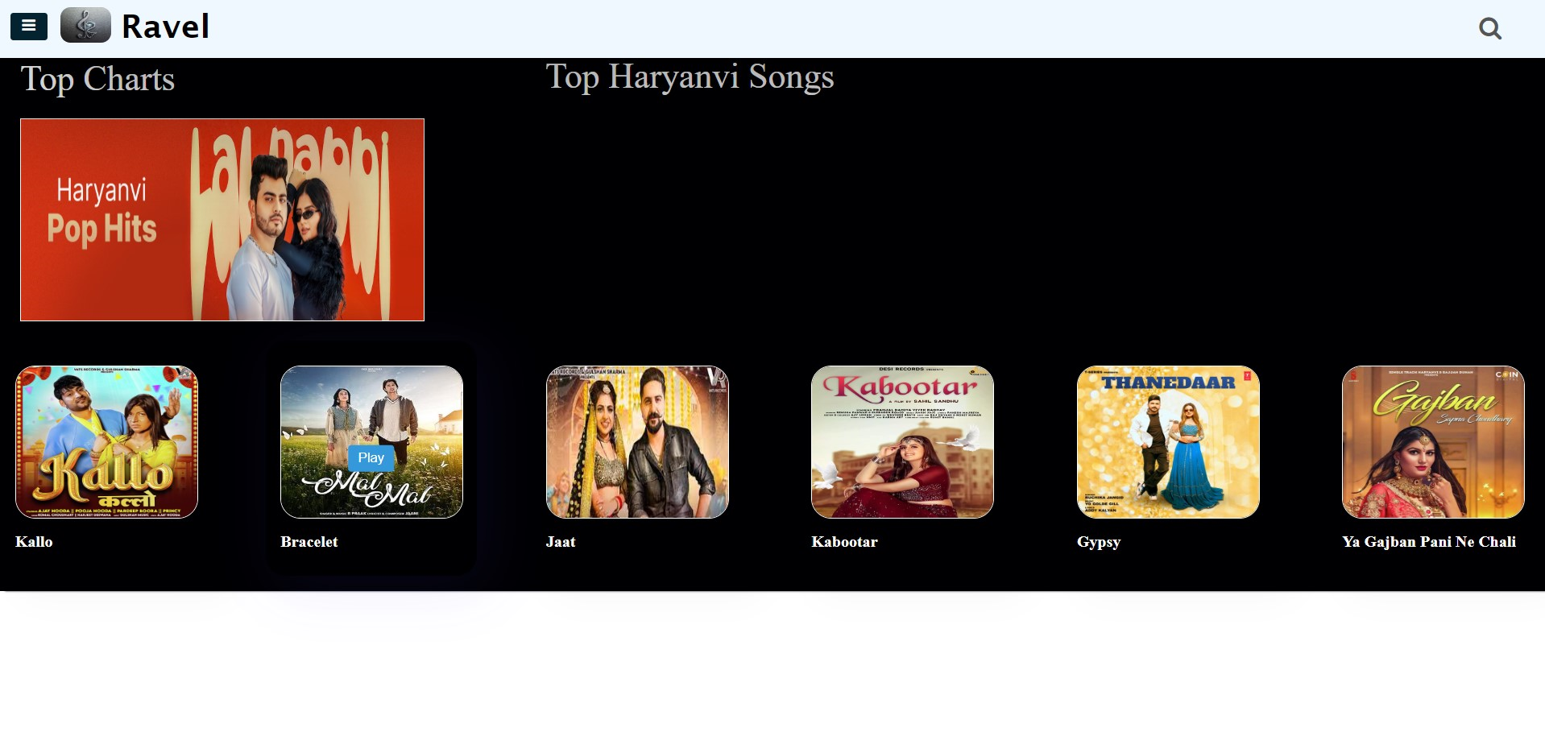

**Fig 5. Top Charts and New Releases**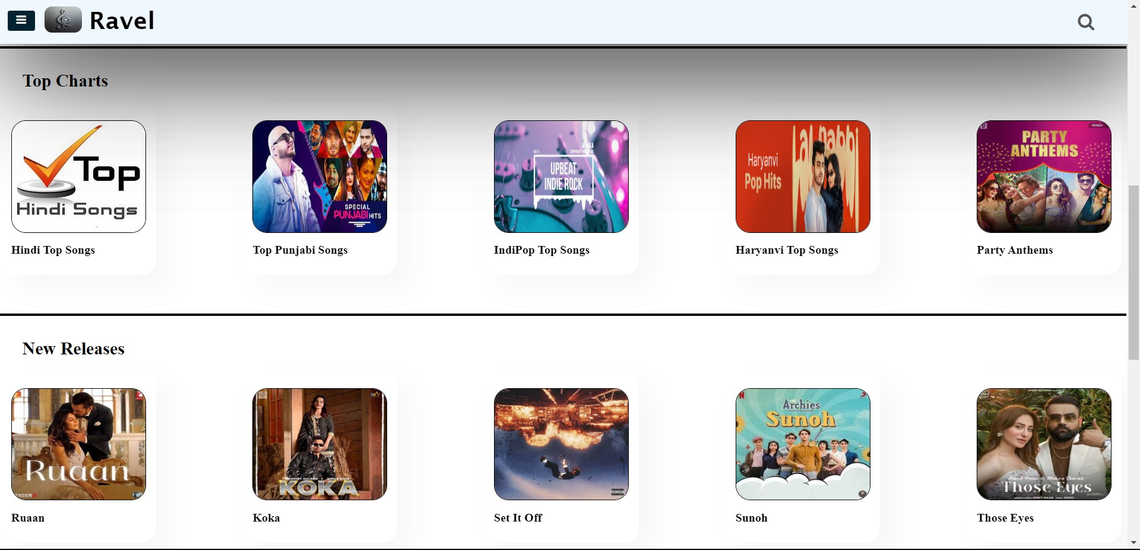

**Fig 6. Top Searched Artist and Popular in Hindi**

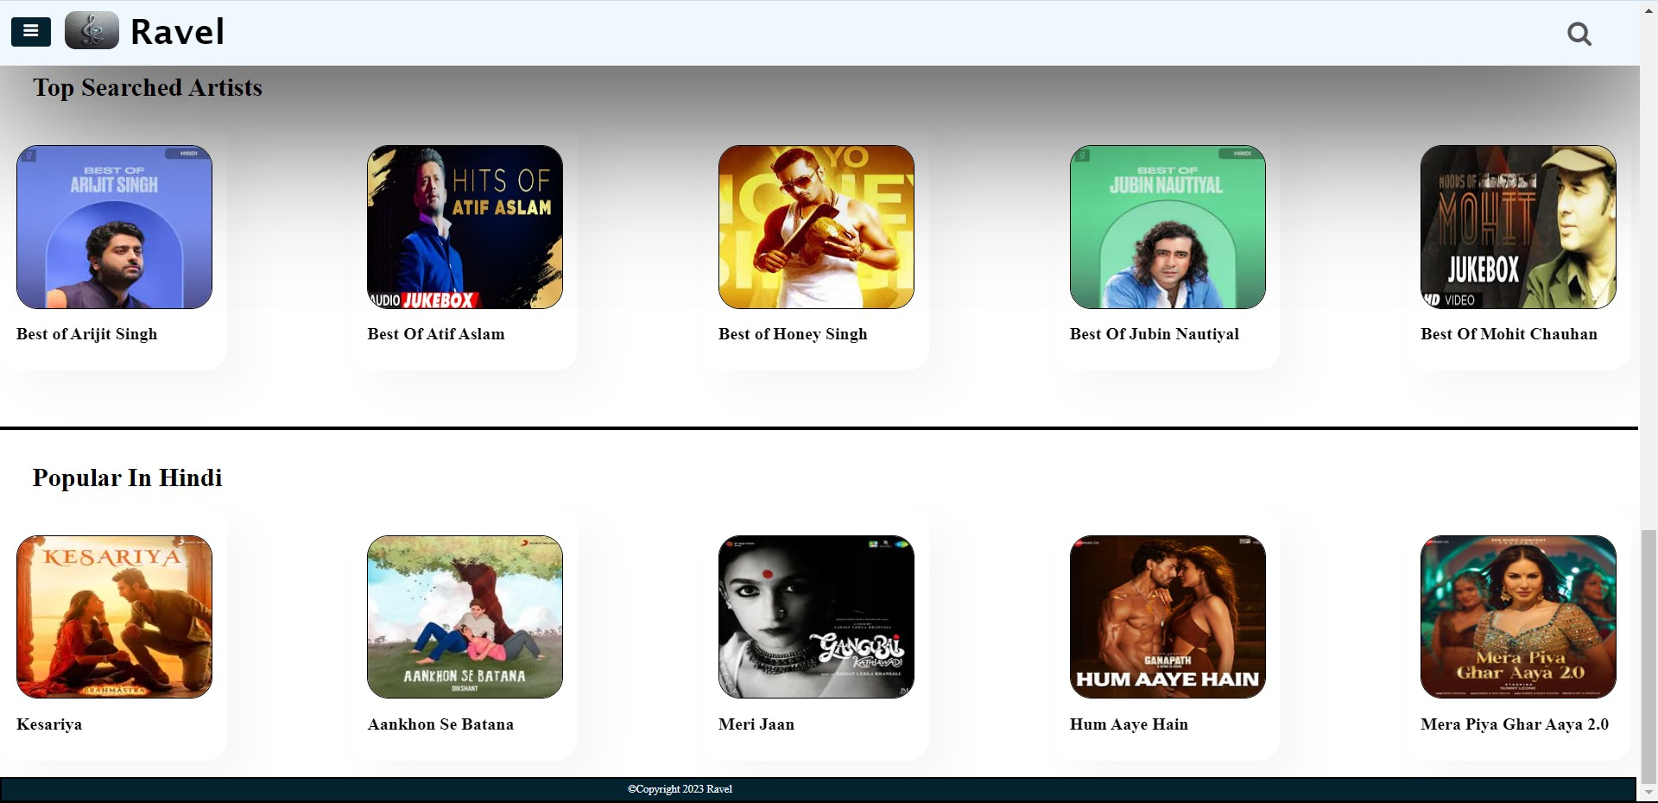

**Fig 7. Search**

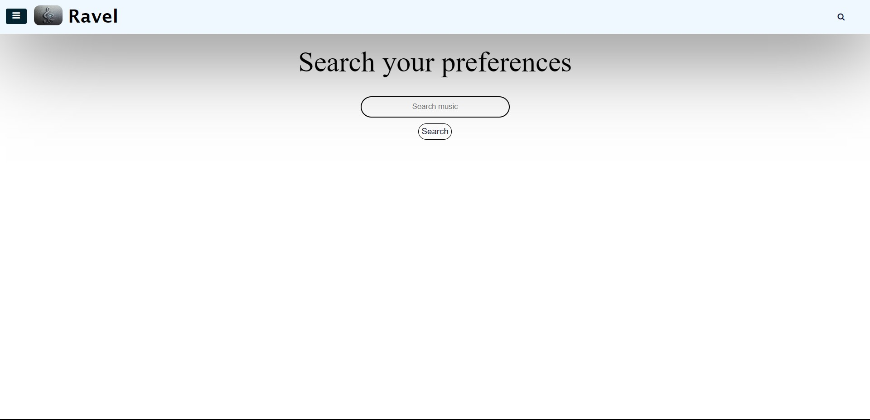

**Fig 8. Searched Music**

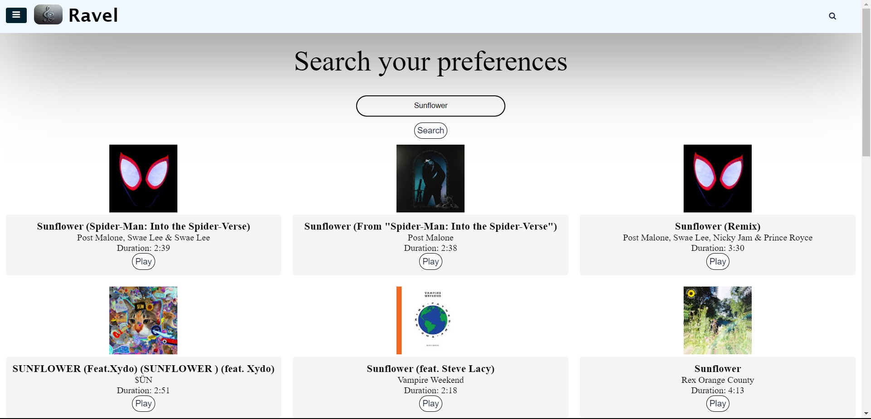

# Fig 12. Footer

# 

# Technologies

##### HTML(Hyper Text Markup Language):-

HTML (Hyper Text Markup Language) is the most basic building block of the Web. It defines the meaning and structure of web content. Other technologies besides HTML are generally used to describe a web page's appearance/presentation (CSS) or functionality/behavior (JavaScript).

##### CSS(Cascading Styling Sheet):-

Cascading Style Sheets (CSS) is a style sheet language used for describing the presentation of a document written in a markup language such as HTML . CSS is a cornerstone technology of the World Wide Web, alongside HTML and JavaScript. CSS is designed to enable the separation of content and presentation, including layout, colors, and fonts.

##### JavaScript :-

JavaScript is a programming language used primarily for creating interactive front-end web applications. It is one of the core technologies used for building modern web applications and is supported by all major web browsers. JavaScript is often used in conjunction with HTML and CSS to create rich, interactive web pages. It is a versatile language that can be used for a variety of purposes, including creating web applications, building mobile applications using frameworks such as React Native and Ionic, and developing server-side applications using Node.js.

### Conclusion

### In conclusion, "Ravel: The Music Buddy" is poised to redefine the landscape of music streaming platforms by offering a sophisticated yet user-friendly experience. The project ambitiously tackles the challenges of music discovery, organization, and playback, placing a premium on personalization, engagement, and security.

### With a diverse music library, seamless registration processes, and a robust recommendation system combining collaborative and content-based filtering, the platform aims to resonate with music enthusiasts of varied tastes. The implementation of high-quality audio streaming, coupled with customizable settings, promises an immersive and enjoyable listening experience.

### The collaborative efforts of the development team, including Abhishek Sagar, Aditya Singh, Aman Kumar, and Sikha Chauhan, under the guidance of Mr. Ankit Arora, project supervisor, underscore a commitment to excellence. The expected outcomes encompass not only the creation of a music platform but the establishment of a vibrant community where users can connect through shared playlists and collaborative creation.

### Success metrics will measure the platform's ability to deliver on its promises—offering a user-friendly environment, a vast and diverse music catalog, and robust security measures in compliance with data protection regulations. As "Ravel: The Music Buddy" strives to elevate the music streaming experience, the project stands as a testament to innovation, user satisfaction, and a harmonious fusion of technology and artistry in the realm of digital music consumption.

### Future work

### While the Music website mini project has provided a solid foundation, there are several avenues for future work and enhancements to further improve the website's functionality and user experience. Some potential areas for future work include:

**Enhanced AI-Based Recommendations:** Integrate advanced artificial intelligence (AI) algorithms to continuously improve and personalize music recommendations based on evolving user preferences and behaviors.

**Intuitive User Interface Updates:** Implement ongoing updates to the user interface, incorporating user feedback and emerging design trends to ensure a continuously intuitive and engaging platform.

**Global Music Inclusion:** Expand the music library to include a more extensive and diverse collection of global music, catering to a broader audience and promoting cultural inclusivity.

**Augmented Reality (AR) Integration**: Explore the integration of augmented reality features to provide users with immersive experiences, such as virtual concert simulations or interactive album artwork.

**Blockchain for Royalties and Copyright Management:** Investigate blockchain technology for transparent and efficient management of royalties and copyrights, ensuring fair compensation for artists and copyright holders.

**Offline Listening and Download Options:** Develop offline listening capabilities and download options, allowing users to enjoy their favorite music even in areas with limited or no internet connectivity.

**Voice-Activated Commands:** Implement voice-activated commands for hands-free control, offering users a convenient and accessible way to interact with the platform while engaged in other activities.

**Integration with Social Media Platforms:** Strengthen social interactions by integrating with popular social media platforms, allowing users to share their music activities seamlessly and enhancing the overall social experience.

**Live Streaming and Virtual Concerts:** Explore features for live streaming and virtual concerts, providing users with real-time access to performances and events, further enriching the overall music experience.

**Continuous Security Upgrades:** Stay vigilant against evolving cybersecurity threats by implementing continuous security upgrades and adopting the latest encryption standards to protect user data.

**User-Generated Content and Playlists:** Facilitate user-generated content by allowing users to contribute their playlists, reviews, and content, fostering a sense of community and collaboration.

**Cross-Platform Compatibility:** Develop compatibility with a broader range of devices and platforms, ensuring users can seamlessly transition between various devices without compromising the user experience.

These future works aim to propel "Ravel: The Music Buddy" beyond its initial scope, ensuring the platform remains at the forefront of innovation, user satisfaction, and the ever-evolving landscape of digital music consumption.

### Reference

#### Websites

* 1. <https://github.com/>
  2. <https://gaana.com/>

#### GitHub Repository Link

<https://github.com/Aditya-Singh-cs/Ravel-The-Music-Buddy>

**Main HTML :**

<!DOCTYPE html>

<html lang="en">

<head>

    <meta charset="UTF-8">

    <meta name="viewport" content="width=device-width, initial-scale=1.0">

    <title>Ravel</title>

    <link rel="stylesheet" href="http://maxcdn.bootstrapcdn.com/font-awesome/4.3.0/css/font-awesome.min.css">

    <link rel="stylesheet" href="http://fortawesome.github.io/Font-Awesome/assets/font-awesome/css/font-awesome.css">

    <link rel="stylesheet" href="style.css">

    <script src="/api.js"></script>

</head>

<body>

    <section id="header1">

        <div class="logo">

            <div>

                <input type="checkbox" id="check">

                <label for="check">

                    <i class="fa fa-bars" id="btn"></i>

                    <h6 class="&#10799" id="cancel">X</h6>

                </label>

                <div class="sidebar">

                    <header><strong>Dashboard</strong></header>

                    <ul>

                        <li><a href="index.html">Home</a></li>

                        <li><a id="Ts" href="#Trending_Songs"><b>Trending Now</b></a></li>

                        <li><a id="Ts" href="#Top_Charts"><b>Albums</b></a></li>

                        <li><a id="Ts" href="#Top_Artist"><b>Top Artist</b></a></li>

                    </ul>

                </div>

            </div>

            <div>

                <a href="index.html"><img

                        src="https://images-platform.99static.com//Qci1XFMigg8KyofnPwoh2j1gIkU=/369x2306:925x2862/fit-in/590x590/99designs-contests-attachments/56/56303/attachment_56303289"></a>

            </div>

            <div>

                <a href="#">

                    <h1><strong>Ravel</strong></h1>

                </a>

            </div>

        </div>

        <div class="search_nav">

            <div class="search">

                <form id="searchForm" action="search.html" method="get">

                    <button type="submit" id="searchBtn" class="fa fa-search"></button>

                </form>

            </div>

        </div>

    </section>

    <!-- <section id="header2"> -->

    <div class="navbar2">

        <ul>

            <li class="active"><a href="index.html"><b><i class="fa fa-home"></i> Home</b></a></li>

            <li><a id="Ts" href="#Trending_Songs"><b>Trending Now</b></a></li>

            <li><a id="Ts" href="#Top_Charts"><b>Albums</b></a></li>

            <li><a id="Ts" href="#Top_Artist"><b>Top Artist</b></a></li>

        </ul>

    </div>

    <!-- </section> -->

    <section id="sm-banner" class="section-p1">

        <div class="banner-box1">

            <a href="#New_Releases"><img

                    src="https://a10.gaanacdn.com/gn_img/showcase/BZgWoOW2d9/ZgWonrr32d/size_m_1698048952.webp"></a>

        </div>

        <div class="banner-box2">

            <a href="#H-Poluplar"><img

                    src="https://a10.gaanacdn.com/gn_img/showcase/lJvKa16KDV/JvKa7m2WDV/size_m_1692937424.webp"></a>

        </div>

    </section>

    <section id="Trending_Songs">

        <div>

            <br>

            <br>

            <hr>

            <h2>Trending Songs</h2>

        </div>

    </section>

    <section id="feature" class="section-p1">

        <div class="fe-box" data-video-id="6GxXehkPyBs">

            <img class="F1"

                    src="https://a10.gaanacdn.com/gn_img/albums/d41WjnWPLq/1WjwjpeobP/size_m_1698057396.webp" style="border: 1px solid black;">

            <h4>Leke Prabhu Ka Naam...</h4>

          <button class="play-button">Play</button>

        </div>

        <div class="fe-box" data-video-id="5oExKMYIE9U">

            <img class="F1"

                    src="https://a10.gaanacdn.com/gn_img/albums/R7vKX6WmrP/vKXrNk9vWm/size_m.jpg" style="border: 1px solid black;">

            <h4>Kalaastar (From "Hone...</h4>

            <button class="play-button">Play</button>

        </div>

        <div class="fe-box" data-video-id="7VppHj0Rue0">

            <img class="F1"

                    src="https://a10.gaanacdn.com/gn_img/albums/6Zxb27K9wN/xb2qrjNoW9/size_m_1688020211.webp" style="border: 1px solid black;">

            <h4>Udd Jaa Kaale Kaava...</h4>

            <button class="play-button">Play</button>

        </div>

        <div class="fe-box" data-video-id="HRA1us5ArXc">

            <img class="F1"

                    src="https://a10.gaanacdn.com/gn_img/albums/lJvKa63DV9/vKa57z04KD/size_m.jpg" style="border: 1px solid black;">

            <h4>Gaadi Kaali</h4>

            <button class="play-button">Play</button>

        </div>

        <div class="fe-box" data-video-id="seEO3--Sy3c">

            <img class="F1"

                    src="https://a10.gaanacdn.com/gn_img/albums/mGjKrP1W6z/jKrrP07JK6/size_m.jpg" style="border: 1px solid black;">

            <h4>Chorni</h4>

            <button class="play-button">Play</button>

        </div>

        <!-- <div class="fe-box" data-video-id="CDIF_kq1GWs">

            <img class="F1"

                    src="https://a10.gaanacdn.com/gn_img/albums/9En3peWXDV/n3pkqg08KX/size_m.jpg">

            <h4>Gustaakhiyan</h4>

            <button class="play-button">Play</button>

        </div> -->

    </section>

    <section id="Top_Charts">

        <div>

            <br>

            <br>

            <hr>

            <h2>Top Charts</h2>

        </div>

    </section>

    <section id="feature" class="section-p1">

        <div class="fe-box">

            <a href="tc1.html"><img class="F1"

                    src="https://encrypted-tbn0.gstatic.com/images?q=tbn:ANd9GcTlWDbX2aynu81WaTlykNoPDEBZPAv5n2p1KA&usqp=CAU" style="border: 1px solid black;"></a>

            <h4>Hindi Top Songs</h4>

        </div>

        <div class="fe-box">

            <a href="tc2.html"><img class="F1"

                    src="https://encrypted-tbn0.gstatic.com/images?q=tbn:ANd9GcSH8dFFwSl5M_NkoYbbfsRq0zMQzbudvs_u3I5BHh5wmcZlYS31g0E8vBWx4s9rlvIx06A&usqp=CAU " style="border: 1px solid black;"></a>

            <h4>Top Punjabi Songs</h4>

        </div>

        <!-- <div class="fe-box">

            <a href="tc3.html"><img class="F1"

                    src="https://encrypted-tbn0.gstatic.com/images?q=tbn:ANd9GcS1SZaVxnu3alNfu4D9ybGvtbqytqDH0v8TQ4wQxCHabuEzdPfKHwkWqi-RNQ27WBCzkFQ&usqp=CAU"></a>

            <h4>Old Original Songs</h4>

        </div> -->

        <div class="fe-box">

            <a href="tc3.html"><img class="F1"

                    src="https://i.ytimg.com/vi/fYd5zprDwTo/maxresdefault.jpg" style="border: 1px solid black;"></a>

            <h4>IndiPop Top Songs</h4>

        </div>

        <div class="fe-box">

            <a href="tc4.html"><img class="F1"

                src="https://s3.ap-south-1.amazonaws.com/discovery-prod-arsenal/arsenal/artworks/65325aad9d880b609bd1e0a3/BANNER_97801951627771.jpeg" style="border: 1px solid black;"></a>

                <h4>Haryanvi Top Songs</h4>

        </div>

        <div class="fe-box">

            <a href="tc5.html"><img class="F1"

                    src="https://a10.gaanacdn.com/gn_pl_img/playlists/qa4WEqWP1p/4WEkMOE5KP/size_m_1699268011.webp" style="border: 1px solid black;"></a>

            <h4>Party Anthems</h4>

        </div>

    </section>

    <section id="New_Releases">

        <div>

            <br>

            <br>

            <hr>

            <h2>New Releases</h2>

        </div>

    </section>

    <section id="feature" class="section-p1">

        <div class="fe-box" data-video-id="OPazrdwYAm0">

            <img class="F1"

                    src="https://a10.gaanacdn.com/gn_img/albums/4Z9bqZoKyQ/9bqZjqxXKy/size_m.jpg" style="border: 1px solid black;">

            <h4>Ruaan</h4>

            <button class="play-button">Play</button>

        </div>

        <div class="fe-box" data-video-id="Ji-pwt2CTLw">

            <img class="F1"

                    src="https://a10.gaanacdn.com/gn_img/albums/0wrb4kNWLg/rb4k8ArAWL/size_m.jpg" style="border: 1px solid black;">

            <h4>Koka</h4>

            <button class="play-button">Play</button>

        </div>

        <div class="fe-box" data-video-id="aJnkn1orM9Y">

            <img class="F1"

                    src="https://a10.gaanacdn.com/gn_img/albums/XzVWRLKdqR/VWRvwxZaWd/size_m.jpg" style="border: 1px solid black;">

            <h4>Set It Off</h4>

            <button class="play-button">Play</button>

        </div>

        <div class="fe-box" data-video-id="9ozRrelI7jc">

            <img class="F1"

                    src="https://a10.gaanacdn.com/gn_img/albums/Oxd3xP3gVY/d3xDkXg93g/size_m.jpg" style="border: 1px solid black;">

            <h4>Sunoh</h4>

            <button class="play-button">Play</button>

        </div>

        <div class="fe-box" data-video-id="i9UDD6zyCGs">

            <img class="F1"

                    src="https://a10.gaanacdn.com/gn_img/albums/kGxbnw0Ky4/xbn1mG1MWy/size_m.jpg" style="border: 1px solid black;">

            <h4>Those Eyes</h4>

            <button class="play-button">Play</button>

        </div>

        <!-- <div class="fe-box" data-video-id="Xty2gi5cMa8">

            <img class="F1"

                    src="https://a10.gaanacdn.com/gn_img/albums/2lV3d1WRgB/V3dZmlBobR/size_m.jpg">

            <h4>For all the Dogs</h4>

            <button class="play-button">Play</button>

        </div> -->

    </section>

    <section id="Top_Artist">

        <div>

            <br>

            <br>

            <hr>

            <h2>Top Searched Artists</h2>

        </div>

    </section>

    <section id="feature" class="section-p1">

        <div class="fe-box">

            <a href="ta1.html"><img class="F1"

                    src="https://a10.gaanacdn.com/gn_pl_img/playlists/zLp36v3rGe/Lp36mQk0Kr/size_m_1652464449.webp" style="border: 1px solid black;"></a>

            <h4>Best of Arijit Singh</h4>

        </div>

        <div class="fe-box">

            <a href="ta2.html"><img class="F1"

                    src="https://i.ytimg.com/vi/32i0WER6auE/mqdefault.jpg?days_since_epoch=19665" style="border: 1px solid black;"></a>

            <h4>Best Of Atif Aslam</h4>

        </div>

        <div class="fe-box">

            <a href="ta3.html"><img class="F1"

                    src="https://encrypted-tbn0.gstatic.com/images?q=tbn:ANd9GcRBccZI48AXYGJ-YWzDanXuHj3dYFg9W2qYf4iKlc3xFFBdbSIrWS8VIg94rd2W3xQd7sA&usqp=CAU" style="border: 1px solid black;"></a>

            <h4>Best of Honey Singh</h4>

        </div>

        <div class="fe-box">

            <a href="ta4.html"><img class="F1"

                    src="https://a10.gaanacdn.com/gn_pl_img/playlists/4Z9bqZoKyQ/9bqqJeOPby/size_m_1652464349.webp" style="border: 1px solid black;"></a>

            <h4>Best Of Jubin Nautiyal</h4>

        </div>

        <div class="fe-box">

            <a href="ta5.html"><img class="F1"

                    src="https://encrypted-tbn0.gstatic.com/images?q=tbn:ANd9GcSJ1sQcgjnmIuQK3mYFsHvLDsK3o__FJVvLgw&usqp=CAU" style="border: 1px solid black;"></a>

            <h4>Best Of Mohit Chauhan</h4>

        </div>

    </section>

    <section id="H-Poluplar">

        <div>

            <br>

            <br>

            <hr>

            <h2>Popular In Hindi</h2>

        </div>

    </section>

    <section id="feature" class="section-p1">

        <div class="fe-box" data-video-id="BddP6PYo2gs">

            <img class="F1"

                    src="https://a10.gaanacdn.com/gn_img/song/z8k3yd1Krx/k3y4gl50Kr/size_m_1658037089.webp" style="border: 1px solid black;">

            <h4>Kesariya</h4>

            <button class="play-button">Play</button>

        </div>

        <div class="fe-box" data-video-id="ZJ34geQLtUE">

            <img class="F1"

                    src="https://a10.gaanacdn.com/gn_img/albums/9MAWe7KyJe/AWe9Jw5wWy/size_m.jpg" style="border: 1px solid black;">

            <h4>Aankhon Se Batana</h4>

            <button class="play-button">Play</button>

        </div>

        <div class="fe-box" data-video-id="ldWFpeu36K0">

            <img class="F1"

                    src="https://a10.gaanacdn.com/gn_img/albums/R7vKX66Wmr/vKX64Ox6Wm/size_m_1645303288.webp" style="border: 1px solid black;">

            <h4>Meri Jaan</h4>

            <button class="play-button">Play</button>

        </div>

        <div class="fe-box" data-video-id="qhg7QXSXxeY">

            <img class="F1"

                    src="https://a10.gaanacdn.com/gn_img/albums/4Z9bqZoKyQ/9bqZ5zoJKy/size_m.jpg" style="border: 1px solid black;">

            <h4>Hum Aaye Hain</h4>

            <button class="play-button">Play</button>

        </div>

        <div class="fe-box" data-video-id="TLHSz08c_Xo">

            <img class="F1"

                    src="https://a10.gaanacdn.com/gn_img/albums/4Z9bqo3yQn/9bqZNgJeKy/size_m.jpg" style="border: 1px solid black;">

            <h4>Mera Piya Ghar Aaya 2.0</h4>

            <button class="play-button">Play</button>

        </div>

        <!-- <div class="fe-box" data-video-id="2EdgAic4nao">

            <img class="F1"

                    src="https://a10.gaanacdn.com/gn_img/albums/21GWwR3pkg/GWwAOZx2Kp/size_m.jpg">

            <h4>JALSA 2.0</h4>

            <button class="play-button">Play</button>

        </div> -->

    </section>

    <footer><p>&copy;Copyright 2023 Ravel</p></footer>

</body>

</html>

**CSS:**

*{

    margin: 0;

    padding: 0;

    list-style: none;

    text-decoration: none;

}

#header1{

    display: flex;

    align-items: center;

    justify-content: space-between;

    padding: 15px 20px;

    background: aliceblue;

    position: sticky;

    height: 30px;

    top: 0;

    left: 0;

    box-shadow: 10px 10px 150px;

    z-index: 4;

}

.sidebar{

    position: fixed;

    left: -250px;

    width: 240px;

    height: 100%;

    background: #04202d;

    border-radius: 5px;

}

.sidebar header{

    font-size: 22px;

    color: rgb(239, 233, 233);

    text-align: center;

    line-height: 70px;

    background: #031118;

    user-select: none;

    font-weight: 900;

    height: 60px;

}

.sidebar ul a{

    display: block;

    height: 100%;

    width: 100%;

    line-height: 45px;

    font-size: 20px;

    padding-left: 40px;

    box-sizing: border-box;

    border-top: 2px solid rgba(255,255,255,.1);

    border-bottom: 2px solid black;

    transition: .3s;

    color: white;

}

.sidebar ul li:hover a{

    padding-left: 50px;

}

#check{

    display: none;

}

label #btn, label #cancel{

    position: absolute;

    cursor: pointer;

    border-radius: 3px;

}

label #btn{

    left: 10px;

    top: 15px;

    font-size: 15px;

    color: white;

    padding: 6px 12px;

    background: #042331;

    transition: .5s;

}

label #cancel{

    z-index: 1111;

    left: -195px;

    top: 25px;

    font-size: 10px;

    color: #0a5275;

    padding: 5px 5px;

    height: 10px;

    color: rgb(240, 240, 234);

    /* font-weight: 700; */

    background: #042331;

}

#check:checked ~ .sidebar{

    left: 0;

    top: 0px;

}

#check:checked ~ label #btn{

    left: 250px;

    opacity: 0;

    pointer-events: none;

}

#check:checked ~ label #cancel{

    left: 205px;

}

.logo{

    display: flex;

    align-items: left;

    justify-content: space-between;

    gap: 10px;

    margin-left: 30px;

}

.logo a{

    text-decoration: none;

    color: black;

}

#header1 img{

    width: 50px;

    height: 35px;

    border-radius: 10px;

}

#header1 h1{

   font-size: 2rem;

   padding-bottom: 3px;

   font-family:'Lucida Sans', 'Lucida Sans Regular', 'Lucida Grande', 'Lucida Sans Unicode', Geneva, Verdana, sans-serif;

}

.search {

    float: left;

    margin: 7px;

}

.search button {

    background-color: transparent;

    border: none;

    color: #555;

    font-size: 24px;

    cursor: pointer;

    margin-left: -40px;

}

.search button:hover {

    color: #000;

}

.navbar2 .active a::after{

    content: "";

    width: 100%;

    height: 2px;

    background: #e8eded;

    position: absolute;

    bottom: -4px;

    left: 0px;

    opacity: 1;

    transition: all 0.2s;

    pointer-events: none;

    top: 36px;

}

.navbar2{

    display: flex;

    align-items: center;

    justify-content: space-evenly;

    padding: 15px 10px;

    background: rgb(19, 26, 62);

    position: sticky;

    height: 30px;

    top: 0;

    left: 0;

    box-shadow: 10px 10px 150px;

}

.navbar2 ul{

    list-style: none;

    display: flex;

    gap: 70px;

    margin-right: 20px;

}

.navbar2 ul li{

    padding: 10px 7px;

    position: relative;

}

.navbar2 ul li a{

    color: rgb(243, 239, 239);

    text-decoration: none;

    font-size: 15px;

    font-size: 0.900rem;

    transition: all 0.1s;

}

.navbar2 a::after{

    content: "";

    width: 100%;

    height: 2px;

    background: #e8eded;

    position: absolute;

    bottom: -4px;

    left: 0px;

    opacity: 0;

    transition: all 0.2s;

    pointer-events: none;

    top: 36px;

}

.navbar2 a:hover:after{

    opacity: 1;

}

#sm-banner{

    display: flex;

    justify-content: space-evenly;

    align-items: center;

    flex-wrap: wrap;

}

#sm-banner .banner-box1{

    display: flex;

    flex-direction: column;

    justify-content: center;

    align-items: center;

    text-align: center;

    background-size: cover;

    background-position: center;

    margin-top: 30px;

}

#sm-banner .banner-box2{

    display: flex;

    flex-direction: column;

    justify-content: center;

    align-items: center;

    text-align: center;

    background-size: cover;

    background-position: center;

    margin-top: 30px;

}

#sm-banner img{

    height: 250px;

    width: 600px;

}

#feature{

    display: flex;

    flex-direction: row;

    flex-wrap: wrap;

    align-items: center;

    justify-content: space-between;

    margin-right: 8px;

}

#feature .fe-box{

    width: 180px;

    text-align: center;

    padding: 25px 15px;

    box-shadow: 20px 20px 34px rgba(0,0,0,0.03);

    margin: 15px 0;

    border-radius: 20px;

}

.F1{

    width: 300px;

    height: 150px;

    object-fit: fill;

    border-radius: 20px;

}

#feature .fe-box:hover{

    box-shadow: 20px 20px 54px rgba(70,62,221,0.1);

}

#feature .fe-box h4{

    float: left;

}

#feature .fe-box img{

    width: 100%;

    margin-bottom: 10px;

}

hr{

    border: 2px solid black;

    width: 99.7%;

}

#Trending_Songs h2{

    padding-left: 30px;

    padding-top: 30px;

    font-weight: 1000;

    font-size: 1.5rem;

}

#New_Releases h2{

    padding-left: 30px;

    padding-top: 30px;

    font-weight: 1000;

    font-size: 1.5rem;

}

#Top_Charts h2{

    padding-left: 30px;

    padding-top: 30px;

    font-weight: 1000;

    font-size: 1.5rem;

}

#Top_Artist h2{

    padding-left: 30px;

    padding-top: 30px;

    font-weight: 1000;

    font-size: 1.5rem;

}

#H-Poluplar h2{

    padding-left: 30px;

    padding-top: 30px;

    font-weight: 1000;

    font-size: 1.5rem;

}

footer{

    border: 2px solid black;

    width: 99.6%;

    height: 20px;

    background-color: #042331;

}

footer p{

    align-items: center;

    margin-left: 580px;

    margin-top: 4px;

    color: aliceblue;

    font-size: 10px;

}

**JavaScript :**

let currentAudioElement = null;

document.addEventListener('DOMContentLoaded', function () {

    const apiKey = '454d47bb48msh2980ec16166ade4p189a32jsnf46d556bd4f3';

    const style = document.createElement('style');

    style.innerHTML = `

        .song {

            display: inline-block;

            width: calc(33.33% - 20px);

            margin: 10px;

            box-sizing: border-box;

        }

        .song img {

            max-width: 100%;

            height: auto;

        }

        .song-details {

            padding: 10px;

            text-align: center;

            background-color: #f5f5f5;

            border-radius: 5px;

        }

        .play-button {

            background-color: #3498db;

            color: #fff;

            border: none;

            padding: 5px 10px;

            border-radius: 3px;

            cursor: pointer;

        }

    `;

    document.head.appendChild(style);

    async function searchMusic(query) {

        const searchUrl = `https://youtube-music-api3.p.rapidapi.com/search?q=${encodeURIComponent(query)}&type=song`;

        const options = {

            method: 'GET',

            headers: {

                'X-RapidAPI-Key': apiKey,

                'X-RapidAPI-Host': 'youtube-music-api3.p.rapidapi.com',

            },

        };

        try {

            const response = await fetch(searchUrl, options);

            const result = await response.json();

            // Clear previous search results

            const searchResultsContainer = document.getElementById('searchResults');

            searchResultsContainer.innerHTML = '';

            // Loop through the results and create HTML elements

            result.result.forEach(song => {

                const songElement = document.createElement('div');

                songElement.classList.add('song');

                songElement.innerHTML = `

                    <center><img src="${song.thumbnail}" alt="${song.title}"></center>

                    <div class="song-details">

                        <h3>${song.title}</h3>

                        <p>${song.author}</p>

                        <p>Duration: ${song.duration}</p>

                        <button class="play-button" data-video-id="${song.videoId}">Play</button>

                    </div>

                `;

                // Add click event listener to play the song

                songElement.querySelector('.play-button').addEventListener('click', function () {

                    const videoId = this.getAttribute('data-video-id');

                    playSong(videoId, songElement);

                });

                searchResultsContainer.appendChild(songElement);

            });

        } catch (error) {

            console.error(error);

        }

    }

    async function playSong(videoId, songElement) {

        // Stop the currently playing song and hide its audio element

        stopCurrentSong();

        const url = `https://youtube-mp36.p.rapidapi.com/dl?id=${videoId}`;

        const options = {

            method: 'GET',

            headers: {

                'X-RapidAPI-Key': '7519adc043msh53cfe9cd313f109p124924jsne59d0f368b0d',

                'X-RapidAPI-Host': 'youtube-mp36.p.rapidapi.com'

            }

        };

        try {

            const response = await fetch(url, options);

            const result = await response.json();

            if (result.status === 'ok') {

                // Extract the song link

                const songLink = result.link;

                // Play the song on the website

                playAudio(songLink, songElement);

            } else {

                console.error('Failed to fetch song link');

            }

        } catch (error) {

            console.error(error);

        }

    }

    function playAudio(songLink, songElement) {

        // Create an audio element

        const audioElement = document.createElement('audio');

        audioElement.style.width = '100%'; // Set the width to 100%

    audioElement.style.position = 'fixed';

    audioElement.style.bottom = '0'; // Stick to the bottom

    audioElement.style.left = '0';

    audioElement.style.zIndex = '999';

        audioElement.controls = true;

        audioElement.setAttribute('data-video-id', songElement.querySelector('.play-button').getAttribute('data-video-id'));

        // Create a source element with the song link

        const sourceElement = document.createElement('source');

        sourceElement.src = songLink;

        sourceElement.type = 'audio/mp3';

        // Append the source element to the audio element

        audioElement.appendChild(sourceElement);

        // Find the container with the play button (within the current songElement)

        const playButtonContainer = songElement.querySelector('.song-details');

        if (playButtonContainer) {

            // Append the audio element to the container

            playButtonContainer.appendChild(audioElement);

            // Play the audio

            audioElement.play();

            // Hide the existing play button

            const playButton = playButtonContainer.querySelector('.play-button');

            if (playButton) {

                playButton.style.display = 'none';

            } else {

                console.error('Play button not found within container with class "song-details".');

            }

            // Save the current audio element for later control

            currentAudioElement = audioElement;

            // Listen for the "ended" event to show the play button again when the song finishes

            audioElement.addEventListener('ended', function () {

                if (playButtonContainer) {

                    // Show the play button again

                    const playButton = playButtonContainer.querySelector('.play-button');

                    if (playButton) {

                        playButton.style.display = 'block';

                    }

                }

                // Remove the audio element

                audioElement.parentNode.removeChild(audioElement);

                currentAudioElement = null;

            });

        } else {

            console.error('Container with class "song-details" not found.');

        }

    }

    function stopCurrentSong() {

        // If there is a currently playing song

        if (currentAudioElement) {

            // Pause the audio

            currentAudioElement.pause();

            // Check if the audio element has a parent node before removing it

            if (currentAudioElement.parentNode) {

                // Find the corresponding play button and show it

                const videoId = currentAudioElement.getAttribute('data-video-id');

                const playButton = document.querySelector(`.play-button[data-video-id="${videoId}"]`);

                if (playButton) {

                    playButton.style.display = 'inline-block';

                }

                // Remove the audio element

                currentAudioElement.parentNode.removeChild(currentAudioElement);

                currentAudioElement = null;

            }

        }

    }

    document.getElementById('searchForm').addEventListener('submit', function (event) {

        event.preventDefault();

        const searchInput = document.getElementById('searchbar');

        if (searchInput) {

            searchMusic(searchInput.value);

        } else {

            console.error('Element with ID "searchbar" not found.');

        }

    });

});